**IMPLEMENTATION OF SDR-BASED RECEIVER USING STM32 AND NR24L01**

*Thesis submitted to the SASTRA Deemed to be University in partial fulfillment of the requirements*

*for the award of the degree of*

**B. Tech Electronics and Communication Engineering**

*Submitted by*

**R. SRINATH**

**124004308**

**K.B. VIJAYARAGHAVAN**

**124004361**

**May 2024**



**SCHOOL OF ELECTRICAL & ELECTRONICS ENGINEERING**

**THANJAVUR, TAMIL NADU, INDIA – 613 401**



**SCHOOL OF ELECTRICAL & ELECTRONICS ENGINEERING THANJAVUR – 613 401**

# Bonafide Certificate

This is to certify that the thesis titled “**Implementation of SDR-based Receiver using STM32 & NRF24L01**” submitted in partial fulfillment of the requirements for the award of the degree of B. Tech. Electronics & Communication Engineering to the SASTRA Deemed to be University, is a bona-fide record of the work done by **Mr. R. SRINATH** (Reg. No 124004308), **Mr. K.B. VIJAYARGHAVAN** (Reg. No 124004361) during the seventh semester of the academic year 2022-23, in the **School of Electrical & Electronics Engineering**, under my supervision. This thesis has not formed the basis for the award of any degree, diploma, associateship, fellowship, or other similar title to any candidate of any University.

**Signature of Project Supervisor :**

**Name with Affiliation :**

**Date : 22 - 05 - 2024**

Project *Viva voc*e held on

**Examiner 1 Examiner 2**



**SCHOOL OF ELECTRICAL & ELECTRONICS ENGINEERING THANJAVUR – 613 401**

# Declaration

We declare that the thesis titled “**Implementation of SDR-based Receiver using STM32 & NRF24L01**” submitted by us is an original work done by us under the guidance of **Dr. JAMES A BASKARADAS, Associate Professor, School of Electrical and Electronics Engineering, SASTRA Deemed to be University** during the seventh semester of the academic year **2023-24**, in the **School of Electrical and Electronics Engineering**. The work is original and wherever we have used materials from other sources, we have given due credit and cited them in the text of the thesis. This thesis has not formed the basis for the award of any degree, diploma, associate-ship, fellowship, or other similar title to any candidate of any University.

**Signature of the candidate(s) :**

**Name of the candidate(s) : 1. Srinath R**

**2. Vijayaraghavan K B**

**Date : 22 - 05 - 2024**

# Acknowledgments

It is a great pleasure for me to present this project to all of you. We would like to acknowledge and thank our parents who had a role to play in making our humble efforts a big success.

We would like to thank **Dr. S. VAIDHYASUBRAMANIAM, our Honorable Vice-Chancellor** for providing us with an opportunity and the necessary infrastructure to carry out this project as a part of our curriculum. We extend our sincere thanks to **Prof. R. CHANDRA MOULI, Registrar,** SASTRA Deemed University for providing the opportunity to pursue this project.

We would like to express my sincere gratitude to my guide **Dr. JAMES A. BASKARADAS (Associate Professor / SEEE)** for providing invaluable guidance, comments, and suggestions throughout the project. It would not have been possible to complete this report in time without his cooperation, continuous help, and monitoring throughout the project.

We would like to thank **Dr. THENMOZHI K (Dean / SEEE)** for providing us with an opportunity to learn various concepts in detail throughout this project course.

We would also like to thank our panel members **Shri PRASATH R K (Professor / SEEE)** & **Dr. MANIKANDAN C (Professor / SEEE)** evaluated and helped us to identify our mistakes, so that we were subsequently able to learn from them to ensure proper execution.

It is our privilege to express our sincerest regards, to **Dr. LENIN PRAKASH S, Technology Development Center,** who helped us during the project.

We extend our sincere regards to **Shri. K G SUJANTH NARAYAN, SASTRA Keysight RFCoE LAB,** SASTRA University who motivated and assisted us during the project.

We take this opportunity to thank all our lecturers who have directly or indirectly helped our project

# Abstract

The Project mainly focuses on designing & creating a Dongle using the STM32 microcontroller chip and the NRF24L01 transceiver chip for 2.4GHz communication with a USB connector. The STM32 microcontroller manages data processing to ensure reliable communication. The nRF24L01 Transceiver chip enables us to transmit and demodulate the receiver data at a low data rate at an S-Band frequency of 2.4GHz. An omnidirectional patch antenna optimizes the signal reception from all directions and is Fabricated at a frequency of 2.4 – 2.5 GHz and a matching impedance of 50 ohms. The Hardware Dongle is connected with a USB connector which enables us to integrate it with various devices. The designing of the Dongle and the omnidirectional patch antenna is accomplished in KiCad and ADS (Keysight). The project was conducted on a single frequency due to its practicality and cost-effectiveness. However, the flexibility exists to extend the project to accommodate a spectrum of frequencies, contingent upon the capabilities of the transceiver chip.

**Table of Contents**

Bonafide Certificate ii

Declaration iii

Acknowledgments iv

Abstract v

List of Figures vi

List of Tables vii

Abbreviations viii

1. INTRODUCTION 1

2. PROPOSED METHODOLOGY 4

2.1 Prototyping with a Development Board 4

2.1.1 STM NUCLEO L496ZG 4

2.1.2 NRF24L01 5

2.1.3 SPI Protocol 6

2.1.4 Coding, Interfacing and Results 7

2.2 PCB DESIGN 9

2.2.1 POWER SUPPLY 11

2.2.2 USB CONNECTOR AND PROTECTION 11

2.2.3 THE MICROCONTROLLER UNIT AND THE DEBUG PINS 12

2.2.4 NRF TRANSCEIVER 12

2.2.5 IMPEDANCE MATCHING AND SMA CONNECTOR 12

2.2.6 TRANSCEIVER CRYSTAL 13

2.3 Antenna Design & Fabrication: 15

2.3.1. Prototype Antenna: 16

2.3.2. Prototype Antenna Fabrication & Testing: 17

2.3.2. MPA Antenna: 19

2.3.3. Antenna Simulation Reading: 21

2.3.4. Antenna Fabrication and Testing: 23

3. CONCLUSION 26

4. FUTURE SCOPE 27

5. REFERENCES 28

# List of Figures

|  |  |  |
| --- | --- | --- |
| **Figure No.** | **Title** | **Page No.** |
| 1.1 | Traditional radio system & SDR-based radio systems | 1 |
| 2.1 | STM32 NUCLEO L496ZG | 5 |
| 2.2 | STM Cube IDE | 5 |
| 2.3 | NRF24L01 development board | 6 |
| 2.4 | Simple SPI block diagram | 6 |
| 2.5 | SPI read operation for NRF24L01 | 7 |
| 2.6 | SPI write operation for NRF24L01 | 7 |
| 2.7 | Register Map | 8 |
| 2.8 | Prototype design | 8 |
| 2.9 | Transmission result on Spectrum Analyzer | 9 |
| 2.10 | PCB Design Prototype | 9 |
| 2.11 | Functional Block diagram of USBLC6-2SC6 | 12 |
| 2.12 | Matching circuit as per datasheet | 13 |
| 2.13 | PCB layers | 13-14 |
| 2.14 | (a)Simulation of Prototype antenna. (b) its reflection coefficients at S11 and S22. | 17 |
| 2.15 | (a)Fabricated Prototype antenna. (b) A straight SMA female RF coaxial connector for SMA male RF antennas. | 18 |
| 2.16 | Matched impedance of the fabricated prototype antenna. | 18 |
| 2.17 | (a) Omnidirectional Patch antenna design in ADS, (b)Antenna Parameters, (c) S11 curve of the designed MPA (Magnitude, Phase, Polar graphs) | 21 |
| 2.18 | Radiation Pattern in 3-D view | 23 |
| 2.19 | Fabricated Proposed Microstrip Patch Antenna. (a)Front view. (b)Back view. | 24 |
| 2.20 | Fabricated MPA antenna at anechoic chamber | 24 |
| 2.21 | Radiation Pattern of Azimuth and Elevation Readings from anechoic chamber. | 25 |
| 2.22 | Radiation Pattern of Azimuth and Elevation Readings for cross-polarization from the anechoic chamber | 25 |

# List of Tables

|  |  |  |
| --- | --- | --- |
| **Table No.** | **Table name** | **Page No.** |
| 2.1 | List of the factors of designed MPA. | 22 |

# Abbreviations

CDA Crossed Dipole Antenna

CNC Computer Numerical Control

EMC Electromagnetic Compatibility

EMI Electromagnetic Interference

MPA Microstrip Patch Antenna

PCB Printed Circuit Board

RP Radiation Pattern

SMA Sub Miniature version A

SPI Serial Peripheral Interface

USB Universal Serial Bus

# INTRODUCTION

Before SDR Systems (Software Defined Radio Communication Systems) arrived, communication systems heavily relied on hardware-based solutions with fixed components. Traditional radio systems were built using dedicated hardware components where each component is perfectly fitted to unique and specific communication protocols and frequency bandwidths. These hardware-centric radio communication systems specifically lacked in the region of flexibility for different bandwidths and were often cumbersome for modification or upgradation. Any changes to this communication protocol to communication protocol or frequency required very extensive changes in the hardware design, leading to significant time and resource investments.

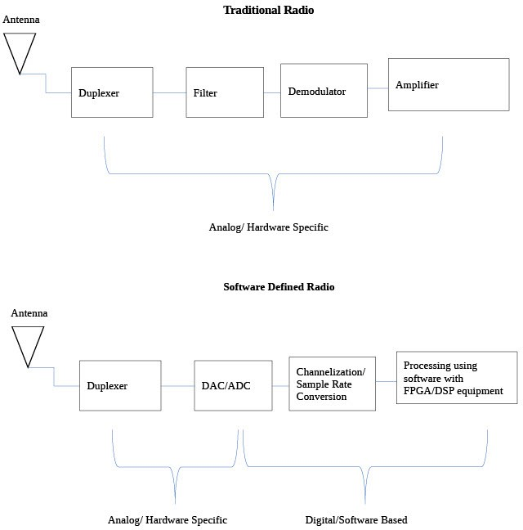Furthermore, the rigid nature of hardware-based communication systems limited their adaptability to evolving technological trends and user requirements. Upgrading or replacing hardware to support the latest standards often incurs substantial costs and downtime. Additionally, the deployment of proprietary hardware solutions resulted in vendor lock-in, restricting interoperability and hindering innovation in the communication ecosystem. These limitations underscored the need for a more flexible and versatile way of radio communication system design and implementation.

*Source: https://shorturl.at/rDRT0*

Fig 1.1: Traditional radio system & SDR-based radio system

In recent years, Software Defined Radio Communication Systems (SDR-System) have emerged as a ground-breaking technology revolutionizing the landscape of wireless communication systems. The SDR offers unparalleled flexibility, allowing the reconfiguration ability of the radio parameters through software, rather than the traditional hardware modifications. This adaptability makes the SDR-based systems highly desirable for various applications, spanning from military and defense to consumer electronics and telecommunications.

The basic SDR-radio systems use the analog-to-digital converter and vice-versa to modulate and demodulate the signal. These data readings are processed by either FPGA or a microcontroller using the programming software to get the required data with a very low noise factor when compared to the traditional hardware radio communication system. This helps the user to transmit and receive the data without any sort of interruption in the wireless signal resulting in an efficient and reliable wireless communication system. It is considered more cost-efficient than the traditional way because it allows its user to change the requirements during testing and can be easily done in software, unlike the conventional analog hardware communication systems.

This Project mainly focuses on the implementation of the SDR-Communication systems using a microcontroller STM32 chip and nRF24L01 transceiver module chip in a Dongle. The STM32 microcontroller family is known for their high performance and versatility, providing an ideal platform for the SDR-based receivers on various applications. The nRF24L01 transceiver module chip is popular for its low power consumption and ease of use, serving as the RF module for receiving and transmitting wireless signals.

The objective of this project is to design and implement a working SDR-based Receiver radio communication system that is capable of receiving the transmitted signal and demodulating it for a wide range of frequencies. By using the capabilities of the STM32 microcontroller and the nRF24L01 transceiver module according to our convenience, this implementation of an SDR-based radio system aims to demonstrate the feasibility of building it more affordable and customizable for amateur radios, wireless sensor networks, and other forms of wireless communication applications which are used in our day-to-day life activities.

In conclusion, SDR-based radio communication systems are revolutionizing the wireless communication sector by delivering quicker and more precise data transmission and reception without the occurrence of interruptions. This technology, will assist users in providing better signal processing and eventually improve signal outcomes by offering a more effective and accurate method of processing the data.

# PROPOSED METHODOLOGY

In the realm of modern wireless communication systems, Communication is a requirement of every individual to connect with a global audience. It provides a virtual platform that provides easy access to share data from one person to another wirelessly. The first step to achieving this objective is to create a communication system that is easy to access and provides data with flexibility, cost-efficiency, efficiency, etc.

The project methodology has been divided into multiple parts and they are as follows:

* + - Prototyping with a Development Board
    - PCB Design
    - Antenna Design, Fabrication & Testing

## 2.1 Prototyping with a Development Board

A development Board is a test PCB board that is made by the manufacturers and comes in different sizes. Each development board has varying capacities concerning available components. Some development boards have only the microcontroller unit (MCU) whereas many sophisticated boards include LEDs, LCDs, CAN, USB, UART, etc. The main advantage of using a development board is that it allows ease of learning, prototyping, and debugging enabling the manufacturers to identify their mistakes and check for efficiency. While choosing a development board we’ll have to consider things like the Clock Speed, Memory, and IOs. The development board used here is ST Microelectronics’ NUCLEO L496ZG.

### 2.1.1 STM NUCLEO L496ZG

This development board hosts STM32L496ZGT6 MCU, based on an ARM Cortex-M4 that has a peak operating frequency of 80 MHz. This also comes with an ST-Link debugger, enabling us to debug easily. It also has built-in peripherals like USB, Timer, UART, SPI, etc. All the STM microcontrollers can be used and coded using the STM Cube IDE.

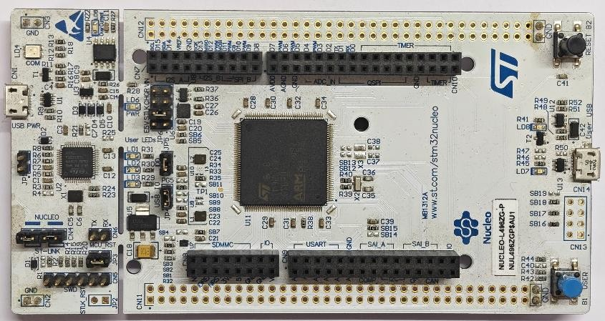 Fig 2.1: STM32 NUCLEO L496ZG

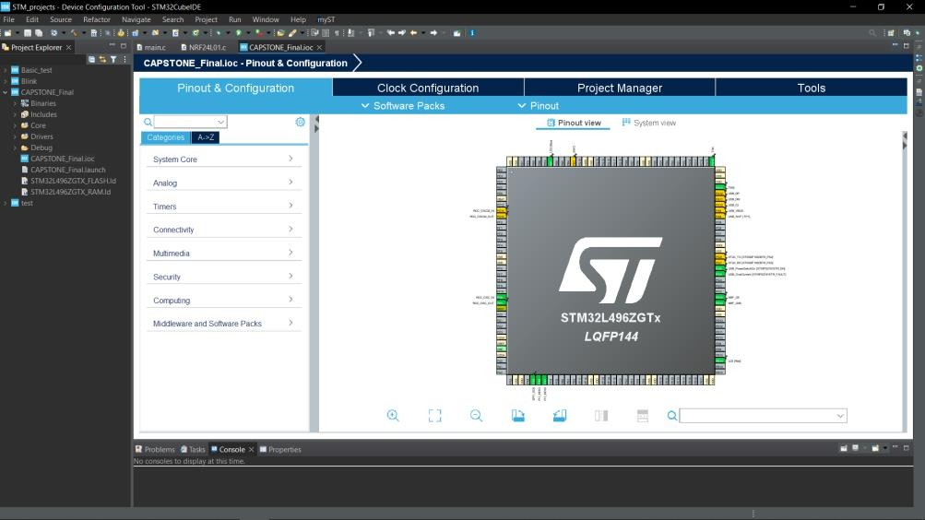

Fig 2.2: STM Cube IDE

Next moving on to the key aspect of the RF system, the transceiver module. There are multiple transceiver modules available in the market like Analog Devices AD9361, NRF24L01, etc. It all depends on the requirements and the budget. As this project involves a demonstration of an SDR, the most viable and cost-friendly option is chosen, NRF24L01 from Nordic Semiconductor.

### NRF24L01

It is a wireless transceiver module that has key features like low power, and low cost and is suitable for various wireless communication systems and RF applications. It operates on the frequency band of 2.4 – 2.525 GHz which is the ISM band. It communicates with the host system using SPI and has varying transmission power and data rate, Multiple channels to avoid congestion, and also proprietary protocol support called Enhanced ShockBurst™ that allows data transmission with minimum overhead. This has an inbuilt modulation block that takes care of modulation and demodulation. The modulation block supports only a type called GFSK (Gaussian Frequency Shift Keying) In the project transmission and reception have been tried using this module with STM32 as the host controller. Now about the protocol that the modules use to communicate, be it configuring the registers of the NRF24L01, sending the transmit payload to the buffer of the transceiver, or receiving the demodulated message from the transceiver. All this is possible because of the SPI protocol.

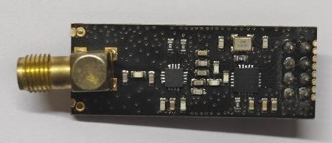

Fig 2.3: NRF24L01 development board

### SPI Protocol

Serial Peripheral Interface is a widely used communication protocol that is a synchronous, full duplex communication that is based on master-slave architecture. It has 4 pins or communication wires SCLK ( Serial Clock ), MOSI (Master Out Slave In ), MISO ( Master In Slave Out ), and CS ( Chip Select ). The chip select chooses the slave to enable communication SCLK gets enabled and data gets transferred in MOSI and MISO lines. SPI has a high data rate of 10Mbps to 20Mbps thereby apt for RF application.

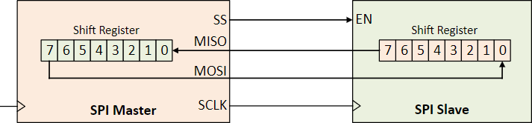

Fig 2.4: Simple SPI block diagram

Image credits: [www.realdigital.org](http://www.realdigital.org/)

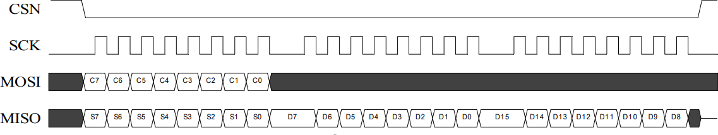 Fig 2.5: SPI read operation for NRF24L01

Image credits: NRF24L01 datasheet

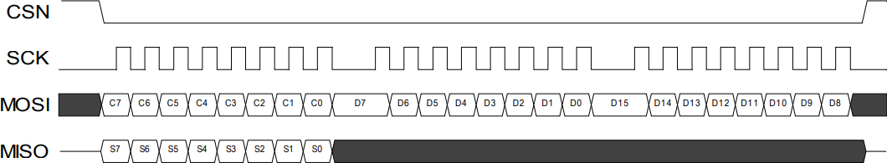

Fig 2.6: SPI write operation for NRF24L01

Image credits: NRF24L01 datasheet

SPI communication has been established between the STM32 Development Board and NRF24L01.

### Coding, Interfacing and Results

#### **2.1.4.1 Coding the STM**

Selecting appropriate GPIO and configuring SPI in the IOC window (Refer Fig.2.1), setting up the external crystal, and configuring the clock for 50 MHz (Maximum allowed is 80 MHz). The next step is writing the code for the Serial Peripheral Interface working and writing up a custom header file for the NRF24L01 referring to the register table from the datasheet of the transceiver IC. Next Map the address from the register map and map it to a header file (named NRF24.h). Write an Embedded C function for initializing the module, read value from the register, update the register, configure the register send the payload to the transmit register, and read data from the receiver buffer.

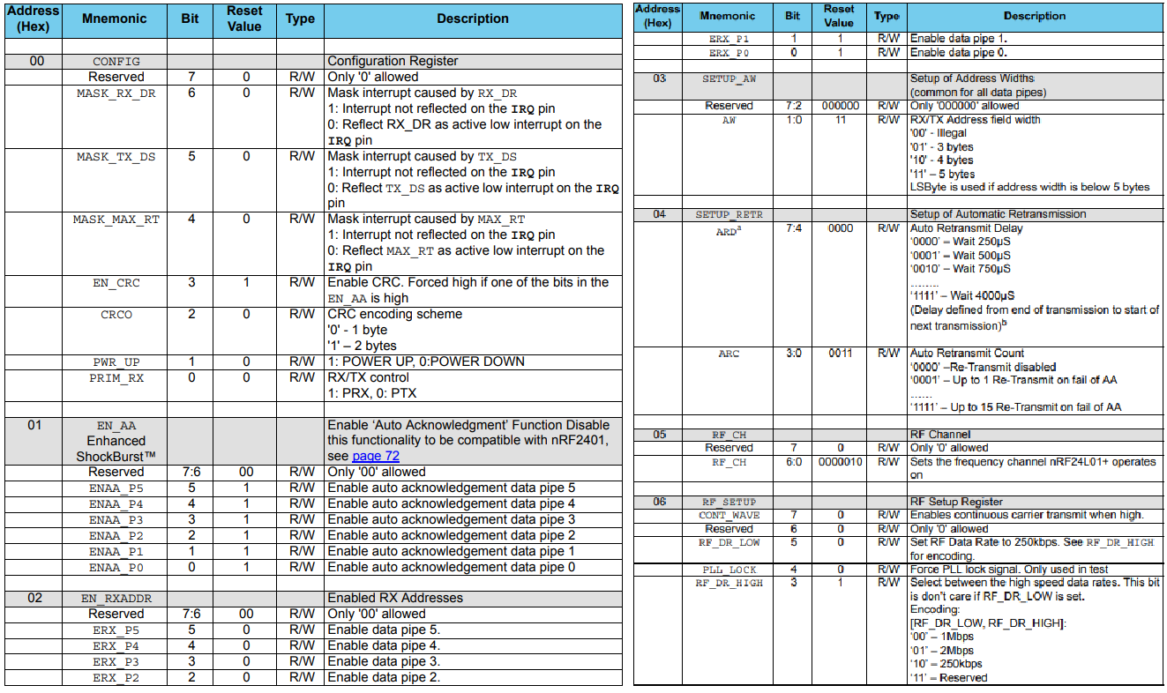

Fig 2.7: Register Map

Image credits: NRF24L01 datasheet

#### **2.1.4.2 Interfacing the Development Boards**

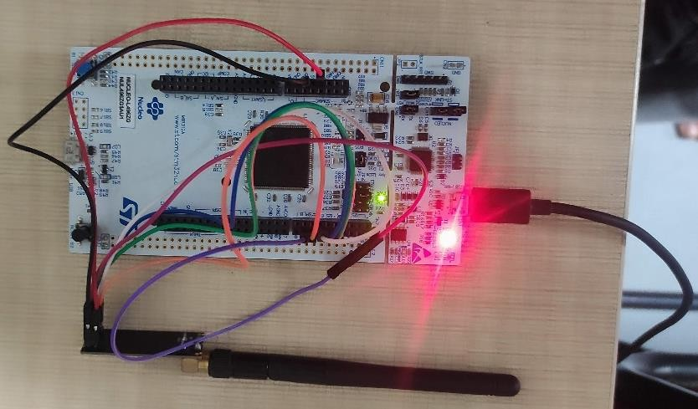

Fig 2.8: Prototype design

Connect the GPIO pin following the pin out of NRF24L01, dump the code, and check for the result in a spectrum analyzer setting up the start and stop frequency and the center frequency as the frequency of what is to be checked. Fix the marker to check the gain and frequency.

#### **2.1.4.3 Testing**

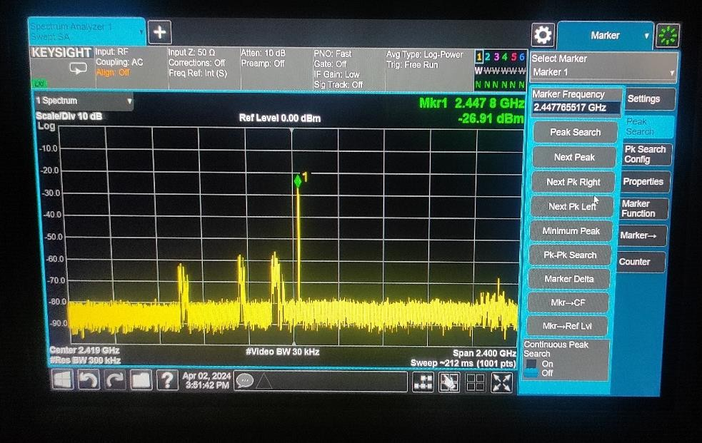

Fig 2.9: Transmission result on Spectrum Analyzer

## PCB DESIGN

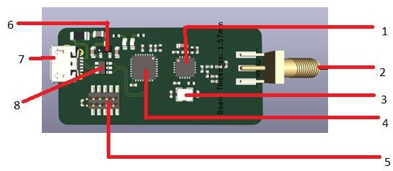

Fig 2.10 PCB Design Prototype

PCB (Printed Circuit Board) are foundational components of modern electronic devices, they provide interconnects and substrates for the operation. Nowadays these have advanced into SMT (Surface Mounting Technology) where drilling of the PCB can be avoided thereby it is easier to make as well as does not compromise the tensile strength of the board.

**KEY FEATURES AND ADVANTAGES OF PCB AND SMT**

* Provides Interconnection platform
* Compact Design
* Customization
* Signal Integrity
* Manufacturing scalability
* Design Flexibility

Now Let us dive deep into the design,

The design intends to develop a prototype that will be able to receive a 2.4GHz signal that is GFSK modulated and demodulated, down-convert, and send the data stream to an STM microcontroller that will act as a data converter and send this data to the computer via a micro - USB port. So, for ease of drawing schematics and designing the board the whole design is broken down into many sub-parts,

1. Power Supply
2. USB connector and Protection
3. The Microcontroller unit and the Debug pins
4. NRF24 Transceiver
5. Antenna Impedance matching and SMA connector
6. Transceiver crystal

The board is a 4-layer board. 4 Layers are generally opted for RF-related design to maintain EMI (Electromagnetic Interference) & EMC (Electromagnetic Compatibility) standards and to avoid mutual coupling between signal layers ground plane separation is used. Through this process, signal integrity is also improved. So, in this design, the layer separations are:

Layer 1 – RF Signal Plane

Layer 2 – Ground Plane

Layer 3 – Power Plane

Layer 4 – Ground Plane

As it is visible RF signal plane and power plane are separated by ground, this is called as ground plane separation. Now we’ll see the prototype design in detail, part by part.

### 2.2.1 POWER SUPPLY

The basic power supply for the entire board is from the micro-USB port. This makes the work easy as the manufacturer of the computer or laptop provides reverse polarity protection along with the motherboard. Reverse polarity protection is key when it comes to any electronic design as it prevents damage, enhances reliability, reduces the risk of fire hazards, and protects equipment from the reverse polarity of the voltage source.

Next is the voltage regulator part. The voltage from the USB is 5V and the voltage required by the STM32 and NRF24L01 as VSS is 3.3V so it is important to regulate 5V to 3.3V. Here a small circuit is implemented with 2 capacitors and a voltage regulator IC (ref 6 in fig 2.10 ASM1117 3.3). One capacitor (10uF) is connected to the input of the IC that effectively reduces Low-frequency noises and the other capacitor(0.1uF) is connected to the output of the IC that effectively reduces high-frequency noises.

A fuse with a rating of 100mA is used at the input. The fuse used here is a polyfuse type that is a resettable type of fuse. A ferrite beat rating of 100 Ω @ 100 MHz is used to reduce or eliminate high-frequency noises.

### USB CONNECTOR AND PROTECTION

Next is the micro-USB (ref 7 in Fig 2.10) connector and its protection. Here the 5V supply is connected to the VCC pin of the USB and the host pin is not grounded as this pin will be grounded on the host side that is the computer that will be used. ESD (Electro Static Discharge) Protection is very much important for USB as it comes in contact with hands very often during the plugging and unplugging of the port. Here an IC called as USBLC6-2SC6 (ref 8 in fig 2.10) is being used that is an IC manufactured by STM microelectronics to which the differential connectors of the USB are given and the output is given to the microcontroller and this IC ensures that static charges do not affect the data via the differential line.

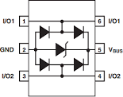

Fig 2.11: Functional Block diagram of

USBLC6-2SC6

### THE MICROCONTROLLER UNIT AND THE DEBUG PINS

The brain of the design, STM32 to which 2 LEDs (Light Emitting Diode) are connected and decoupling capacitors are used for Vdd pins. The importance of a decoupling capacitor is to provide a filtered energy source and also act as a local energy storage bank, whenever a high amount of current is required from the load this supplies and ensures that the microcontroller runs optimally. The SPI pins from the NRF24L01 are connected and the data lines of the USB are also connected thereby it acts as a bridge between the NRF module and the USB. The PH3 pin is grounded with a 10K resistor thereby disabling the debug mode of STM via USB and debugging can only be done with an external debugger. Debug pins (refer to 5 in Fig 2.10) are provided to debug the STM32.

### 2.2.4 NRF TRANSCEIVER

For NRF IC also decoupling capacitors are used at the Vdd pins and here the SPI pins are connected to the STM32, the antenna pins are connected to the antenna part of the matching circuit (refer to Fig 2.12) and the crystal is connected to pins 9 and 10.

### IMPEDANCE MATCHING AND SMA CONNECTOR

Impedance matching is important for maximum power transfer. The antenna is designed for 50 Ω impedance so a matching circuit for 50 Ω is important. An SMA connector is necessary for connecting the antenna to the module so a straight female SMA connector is being used. The matching circuit is provided in the datasheet.

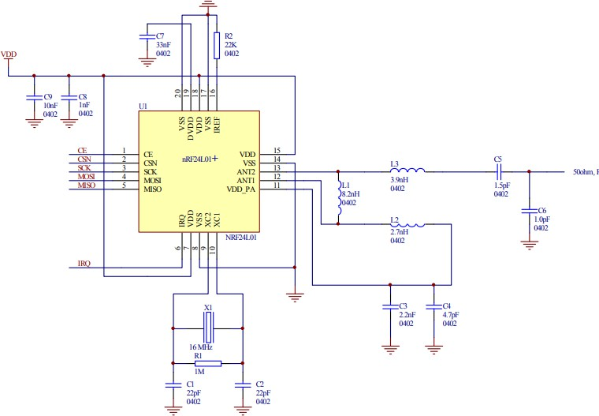

Fig 2.12: The matching circuit as per the datasheet

### 2.2.6 TRANSCEIVER CRYSTAL

A 16MHz transceiver. Usually, crystal is used in transceiver IC to provide a precise timing reference for the transmission and reception of signals. They offer stable oscillations at specific frequencies ensuring accurate synchronization and reliable communication among devices. Two load Capacitors are used on both sides of the crystal to increase the stability (refer fig 2.12)

**INTENDED PCB – LAYER-WISE IMAGE**

Top Layer – RF signal 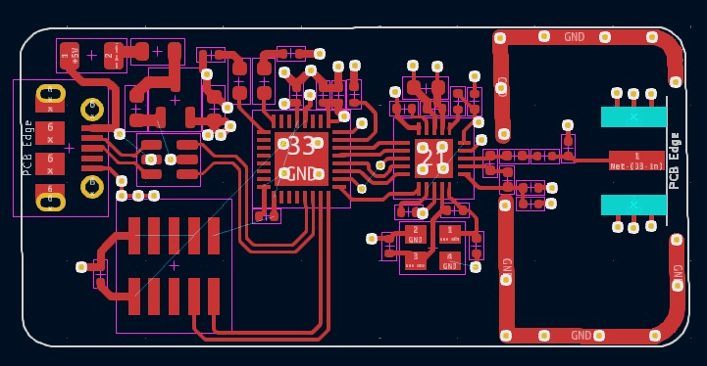

Second Layer – Ground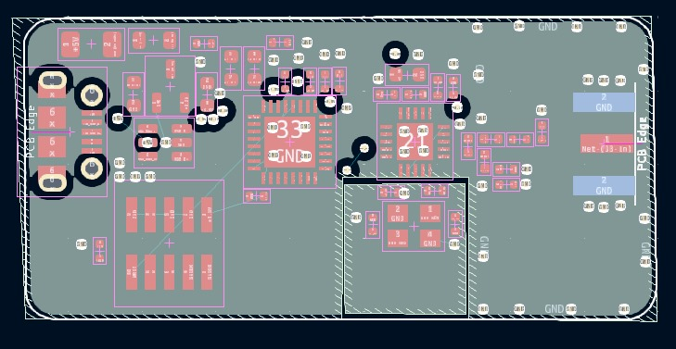

Third Layer – Power Plane 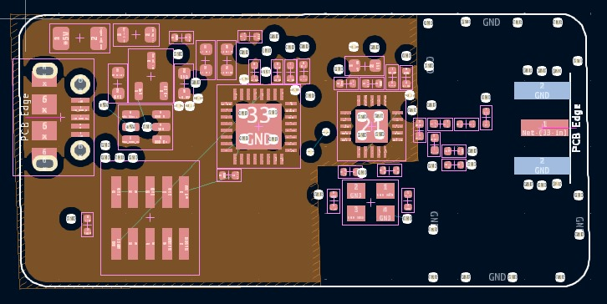

Forth Layer – Ground

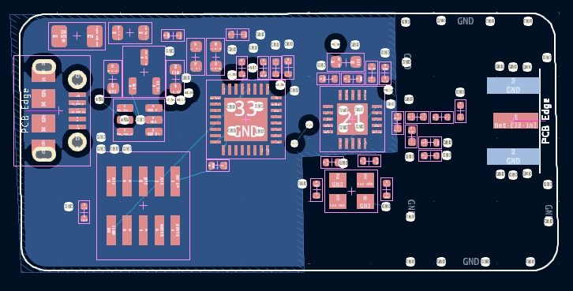

Fig 2.13: PCB layers

## 2.3 Antenna Design & Fabrication:

An antenna is a fundamental component in modern communication systems, serving as the interface between electromagnetic waves propagating through space and electrical signals within electronic devices. Its primary function is to transmit and receive electromagnetic signals efficiently. An antenna is essentially a conductor or a system of conductors that radiates or receives electromagnetic waves. When used for transmission, it converts electrical signals into electromagnetic waves and radiates them into space. When used for reception, it captures incoming electromagnetic waves and converts them back into electrical signals.

The transmission mechanism of an antenna involves the conversion of electrical signals into electromagnetic waves through the antenna's structure. This process relies on the acceleration of charges within the antenna, which generates changing electric and magnetic fields, thus producing electromagnetic radiation. Conversely, during the reception process, the antenna captures incoming electromagnetic waves. The incident electromagnetic field achieves this by inducing an electrical current in the antenna's conductors. This current is then processed by the receiving circuitry.

The fundamental formula for antenna signal transmission is based on the concept of radiation resistance and power radiation. For an ideal isotropic antenna (which radiates power uniformly in all directions), the power radiated (Pr) is related to the transmit power (Pt), wavelength (λ), and antenna gain (G) by the Friis transmission equation:

𝑃𝑟 = 𝑃𝑡.𝐺.λ2

(4𝜋)2.𝑅2 (1.1)

Where: 𝑃 𝑟 = Received power

𝑃 𝑡 = Transmitted power

𝐺 = Antenna gain

𝜆 = Wavelength

𝑅 = Distance between transmitter and receiver

Similarly, for receiving signals, the received power (Pr) is related to the effective aperture (Ae), gain (G), wavelength (λ), and distance (R) by the Friis reception equation:

Friis (1.2)

where: 𝐴 𝑒R = Effective aperture

The antenna is designed, fabricated, and tested to transmit and receive the data signal wirelessly to process it in the dongle using the nRF24L01 transceiver chip and the STM32 microcontroller chip. The antennas mentioned in this report are of two types: -

1. The prototype antenna (crossed dipole antenna frequency at 2.44GHz)
2. Omnidirectional MPA antenna (frequency =2.44GHz)

The specifications, design, fabrication, and result of these antennas are described below briefly:

### Prototype Antenna:

The Prototype antenna is a crossed dipole antenna that was designed by using CST Studio. A crossed dipole antenna is a type of antenna that consists of two perpendicular dipole elements. These dipole elements intersect at their midpoints, forming a cross-like structure. Each dipole element is typically oriented horizontally and vertically, creating polarization diversity. Crossed dipole antennas are commonly used in applications such as satellite communication, radio astronomy, and terrestrial communication systems. The crossed dipole antenna subjected in this report was designed using the CST. They offer advantages such as omnidirectional radiation patterns and polarization diversity, making them suitable for various communication scenarios.

The formation of the proposed prototype antenna is specifically used for the bandwidth range of 2.4GHz to 2.5GHz. The specifications for this crossed dipole antenna (CDA) dictate that each dipole within the CDA measures 17.6 cm in length, and the radius of each cylindrical dipole is 0.45mm. This type of antenna contains four S-Parameters namely S11, S12, S21, and S22. They give us the reflection coefficient between port 1 and port 2 and with themselves due to the amount of power being transmitted due to reverse transmission and the amount of power being sent back due to the presence of the termination port.

**S11:** The reflection coefficient at Port 1, which represents the amount of power reflected to the source when the device is terminated by a matched load.

**S12:** The reverse transmission coefficient, which represents the power transferred from Port 2 to Port 1.

**S21:** The forward transmission coefficient, which represents the power transferred from Port 1 to Port 2.

**S22:** The reflection coefficient at Port 2, which represents the amount of power reflected to the source when the device is terminated by a matched load.

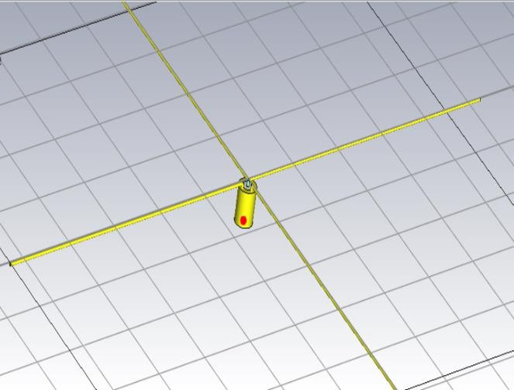

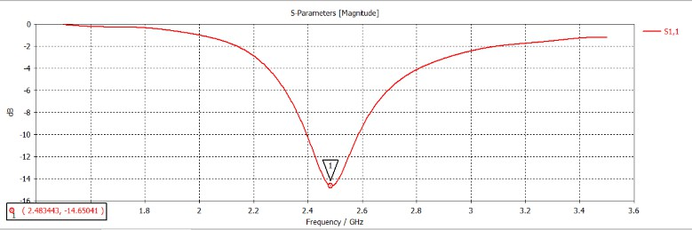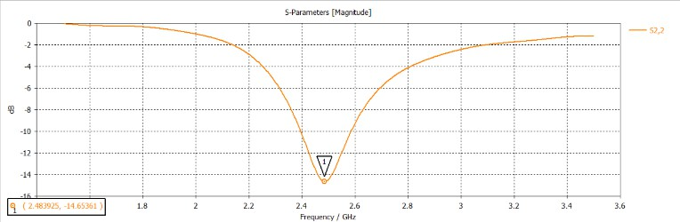

1. (b)

Fig.2.14: (a)Simulation of Prototype antenna. (b) its reflection coefficients at S11 and S22.

The above graph shows us that the reflection coefficient at port 1 with a terminated matched load at port 2 and the reflection coefficient at port 2 with a terminated matched load at port 1 is at the value of -14.6dB of magnitude at a center frequency of 2.48GHz.

### Prototype Antenna Fabrication & Testing:

The fabrication of the prototype CDA antenna is done by using pure copper wire of radius 0.45mm and a monopole of length 8.8 mm. Each monopole is connected to the SMA connector (Sub Miniature version A) which is a type of coaxial RF connector used in various RF applications, especially in telecommunications. The SMA connector is characterized by its small size and threaded coupling mechanism, making it suitable for applications where space is limited and a secure connection is required. The monopoles are connected in such a way that they all are placed perpendicular to each other at 90 degrees

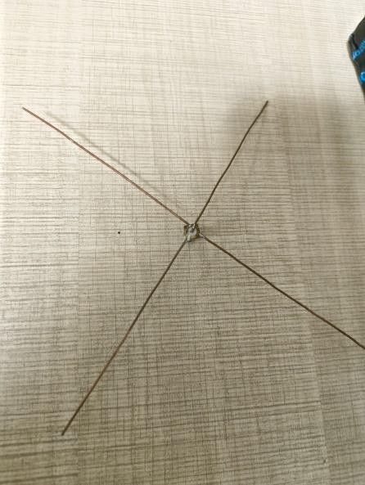

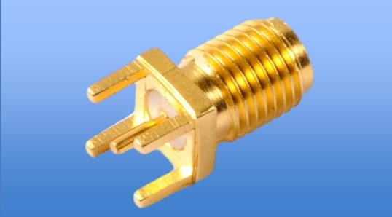

1. (b)

Fig.2.15: (a)Fabricated Prototype antenna. (b) A straight SMA female RF coaxial connector for SMA male RF antennas.

The Prototype CDA antenna is connected to the SMA connector in such a way that the inner copper conductor is connected to the antenna acting as a feed to transmit or receive signal. The outer copper conductor of the SMA connector acts as a ground where the two adjacent monopoles in a crossed dipole are connected to the feed and the other two monopoles are connected to the outer cylindrical copper conductor forming an angle of 90 degrees to each other.

The fabricated CDA antenna from Fig.2.15 (a) is tested using the microwave network analyzer to analyze and characterize the performance of networks, including wired and wireless networks, communication systems, and electrical circuits. It provides us the insights into various network parameters such as signal strength, frequency response, impedance, noise levels, transmission characteristics, etc.

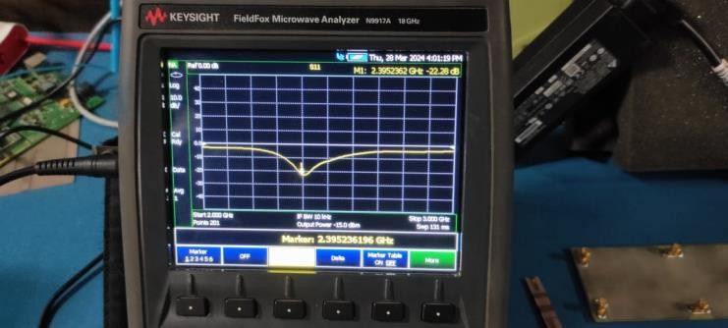

Fig.2.16: Matched impedance of the fabricated prototype antennas

In the provided Fig.2.16, the graphical representation illustrates the S11 parameter of the depicted antenna. The S11 parameter is commonly known as the return loss or reflection coefficient, quantifies the amount of power reflected from the antenna compared to the power incident upon it. In this case, port 2 or one of the dipoles present in the crossed dipole has been terminated to calculate the value of S11.

The dip observed in the S11 parameter graph indicates a significant reduction in reflected power at the center frequency of 2.39GHz. Specifically, the depth of the dip measures approximately -22.28dB, signifying a substantial attenuation of reflected signals at this frequency. Such a pronounced dip suggests effective impedance matching between the antenna and its feeding system, resulting in minimal power loss due to reflections. This characteristic is crucial for maximizing the antenna's efficiency and ensuring optimal performance in transmitting or receiving electromagnetic signals at the specified frequency.

### MPA Antenna:

A microstrip patch antenna mainly consists of a dielectric substrate, with a ground by copper on the other side of the antenna. due to its advantages such as low weight, low profile configuration, low fabrication cost, and capability to integrate with microwave IC technologies, the microstrip patch antenna is very well suited for applications such as wireless communication systems, GPS, cellular phones radar systems, and satellite communication systems.

The MPA antenna that was designed and fabricated acts as a receiver-side antenna to receive the signal with a bandwidth of 2.4GHz to 2.525GHz which can be operated by the nR24L01 IC in the dongle because the ranger is in the ISM band. This antenna is unique compared to other MPA antennas because of its omnidirectional radiation pattern with a directivity of 2.34dBi. So, creating a rose-like MPA antenna with a slotted partial ground plane for sub-6GHz is designed using both CST software and ADS (Keysight) software.

The geometrical formation of the proposed omnidirectional inset-fed MPA (microstrip patch antenna) with a partial ground plane for sub-6GHz band application specifically to the bandwidth of 2.4GHz to 2.525GHz frequency is described below:

The antenna has three tiers namely ground, patch, and substrate. A fragment of FR4 core material is exercised for the antenna and acts as a substrate. The copper (pure) is used for the MPA patch and ground plane. The thickness of the FR4 core and the copper(pure) is 1.575mm and 0.035mm respectively. Initially, the size of the antenna was estimated using some fundamental equations, and then the greatness of the MPA was optimized to 40.5mm x 50mm x 1.645mm by using CST and ADS.

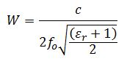 (1.3)

Where c=velocity of light, fr=resonance frequency, and 𝜀𝑟= dielectric constant

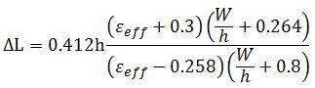 (1.4)

Patch Length, 𝐿𝑝 = 𝐿𝑒𝑓𝑓 − 2𝛥𝐿 (1.5)

The 3D view and fabricated prototype of the MPA are presented below. The width and length of the patch are Wp = 10 mm and Lp = 2.821 mm. There are two rectangular-shaped parasitic elements beside each side of the patch having a width (x) of 10 mm and length (m) of 23 mm. These parasitic elements influence the reflection coefficient as well as the efficiency of the antenna. The intervening space between two parasitic elements (d) is 16 mm. The width (Wf) and length (Lf) of the feeder are 3.0 mm and 21.1mm, respectively. The MPA has a partial ground plane, and the length of this partial ground plane (Lg) is 14.5 mm and a parasitic element at the other side of the MPA has a length (Pl) of 20 mm. The lower part of the back side of the antenna acts as a partial ground plane, and the upper part which is electrically separated but electromagnetically connected acts as a parasitic element. The overall size of this MPA is of L x W = 40.5 mm x 50 mm. The partial ground plane aids to set the antenna omni-directional and the rectangular parasitic elements enhance the directivity of the MPA over the exhaustive working Sub-6 GHz frequency band. The effective impedance of the antenna is completely matched with a 50 Ω port impedance.

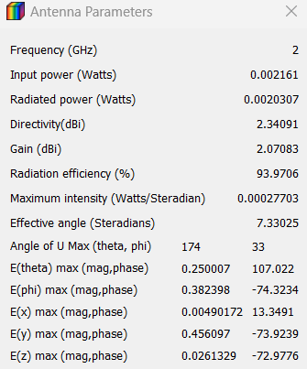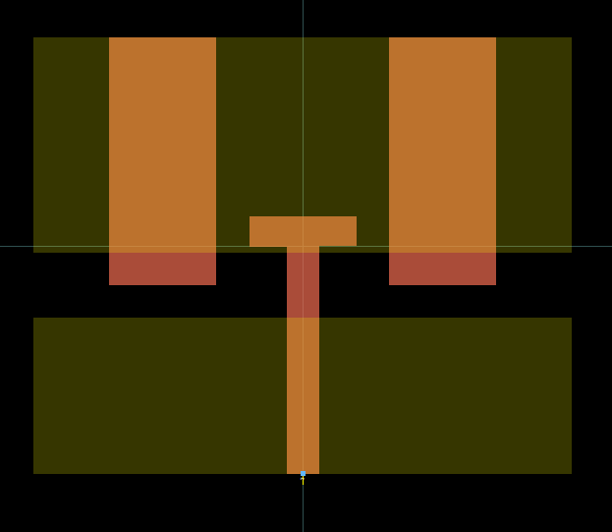

1. (b)

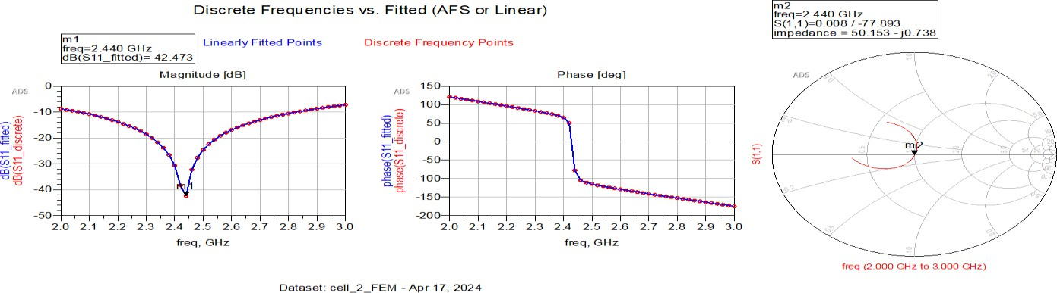

(c)

Fig. 2.17: (a) Omnidirectional Patch antenna design in ADS, (b)Antenna Parameters, (c) S11 curve of the designed MPA (Magnitude, Phase, Polar graphs)

### Antenna Simulation Reading:

The above-mentioned Figure 2.17 (a) exhibits the top and bottom view of the designed omnidirectional patch antenna. Where the necessary dimensions are given below in Table 1. The antenna parameters in the above Figure 2.17 (b) give us the necessary values after simulation of the given antenna design such as the directivity, gain, radiation efficiency, etc. which helps us in the process of antenna fabrication. Now after the simulation of the designed omnidirectional MPA antenna, we get the resonation of the antenna from Figure 2.17 (c) in which the magnitude graph between the scattering parameter (S11) in dB and the frequency in GHz gives us the resonation at the frequency of 2.44GHz with a simulated reflection coefficient of -42.47dB. The polar graph in Figure 2.17 (c) polar graph gives us the matching effective impedance of the simulated omnidirectional MPA antenna to the value of approximately 50 ohms. The simulated operating frequency range covers ranges of the proposed MPA antenna from 2GHz to 2.8GHz. Therefore, the simulated bandwidth is 0.8GHz at the -10dB point of the scattering parameter curve. The bandwidth is quite good for Sub-6GHz bands.

|  |  |
| --- | --- |
| **Parameters for Antenna Design** | **Measurements in mm** |
| Length | 40.5 mm |
| Width | 50 mm |
| Thickness of FR-4 core | 1.575 mm |
| Thickness of copper pure | 0.035 mm |
| Feeders Length | 21.1 mm |
| Feeders width | 3.0 mm |
| Ground plane Length | 14.5 mm |
| Length of parasitic element on ground  plane | 20 mm |
| Length of the parasitic element on the  patch | 23 mm |
| Width of the parasitic element on the  patch | 10 mm |
| Distance between two parasitic  elements of patch | 16 mm |
| Patch’s Width | 10 mm |
| Patch’s Length | 2.821 mm |

Table.2.1: List of the factors of designed MPA.

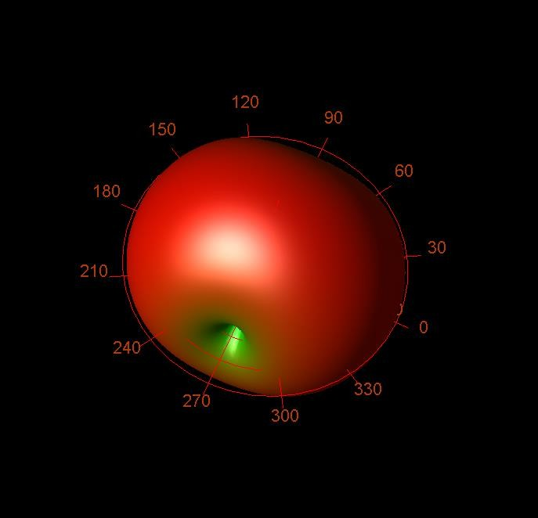

Fig. 2.18: Radiation Pattern in 3-D view

From Figure 2.18 we get to know that our MPA antenna radiates in an omnidirectional radiation pattern at the output of the simulation testing as expected. This radiation pattern is present in a 3-D view and represents the total E- Field radiation of the antenna. This type of radiation pattern is formed by the culmination of E-Theta and E-Phi radiation patterns resulting in omnidirectional R.P. (Radiational Pattern).

### Antenna Fabrication and Testing:

The MPA antenna is fabricated using the CNC machine (computer numerical control machine) precisely without any error. To fabricate a patch antenna, we use three types of software namely copper Cam, Mach 3, and auto leveler. The Gerber file of the MPA antenna design, extracted from ADS, has been forwarded to Copper CAM for the generation of soft copies by detailing the engraving and hatching aspects on both sides of the antenna in a plate with FR4 substrate in between the conducting copper plates. This process facilitates fabrication using the CNC machine. By converting this design into digital instructions using cartesian coordinate system, precise patterns are etched onto the antenna's substrate, ensuring accuracy and reproducibility in the manufacturing process.

We use Mach 3 to engrave and hatch the respective MPA antenna pattern in the plate using the CNC machine. Mach 3 is used to control CNC machines. IT serves as a CNC machine controller, allowing us to convert computer-generated designs into precise machining movements.

Auto leveler is used in this fabrication process before the use of Mach 3. Auto leveler is used to automatically adjust or maintain a level position without manual intervention. Then after fabricating the respected MPA antenna on both the sides of the plate, It is attached with the SMA connector to Provides us an interface to transmit and receive electromagnetic signals from one device to another. The Fig.2.19 gives us the fabricated MPA antenna attached with the SMA connecter.

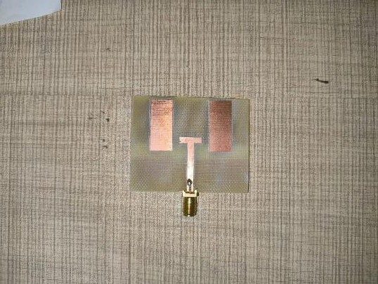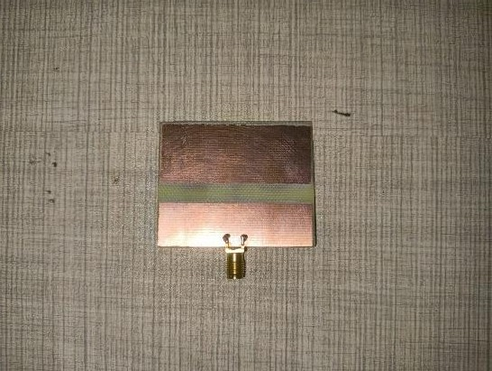

1. (b)

Fig .2.19: Fabricated Proposed Microstrip Patch Antenna. (a)Front view. (b)Back view.

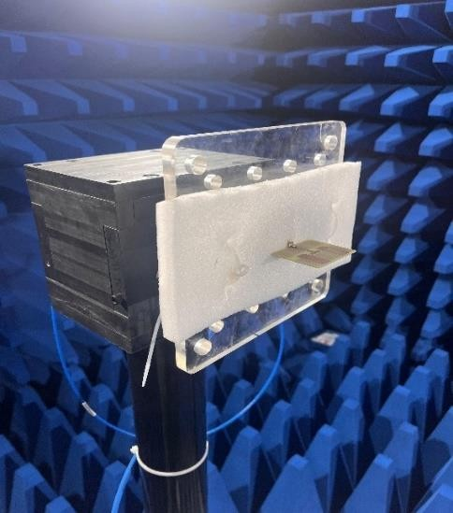The testing of this MPA antenna is done using an anechoic chamber to get the radiation pattern of the fabricated antenna. The results of this MPA antenna is given at the Fig 2.21 and Fig.2.22 describes us the radiation pattern on cross polarization. In cross-polarization, these patterns provide insights into how the antenna behaves for signals polarized perpendicular to its primary polarization direction. azimuth and elevation patterns describe the directional properties of an antenna in the horizontal and vertical planes, respectively, the radiation pattern illustrates the antennas overall radiation characteristics in three-dimensional space.

Fig.2.20: Fabricated MPA antenna at anechoic chamber

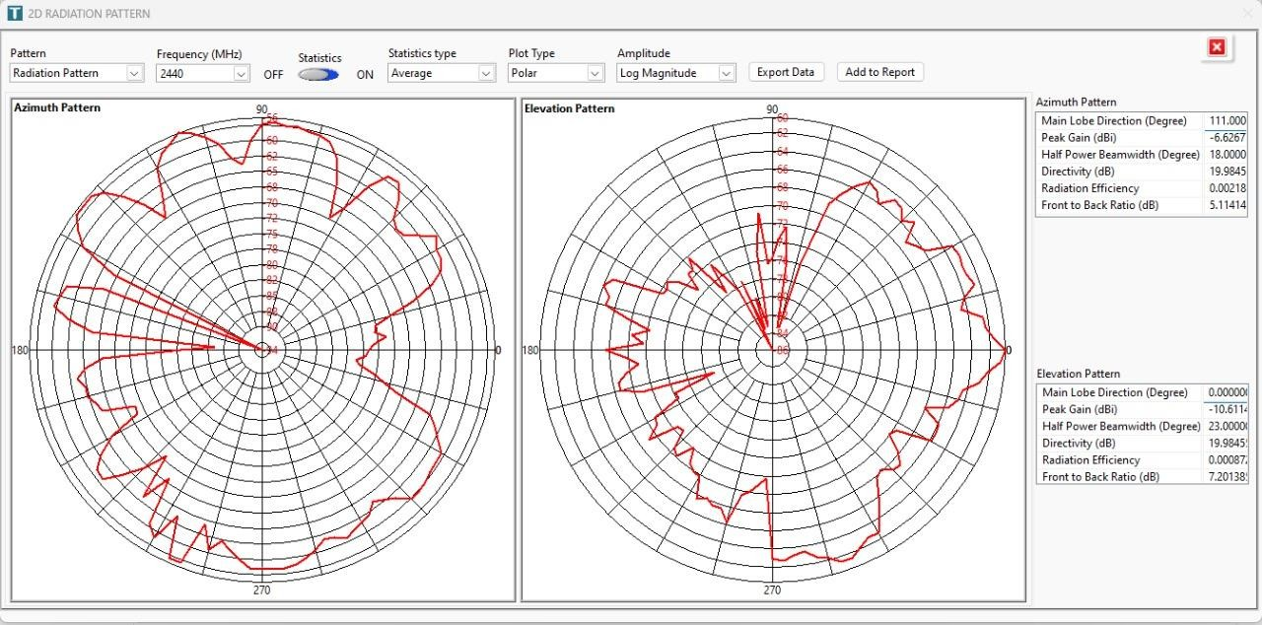

Fig 2.21: Radiation Pattern of Azimuth and Elevation Readings from anechoic chamber.

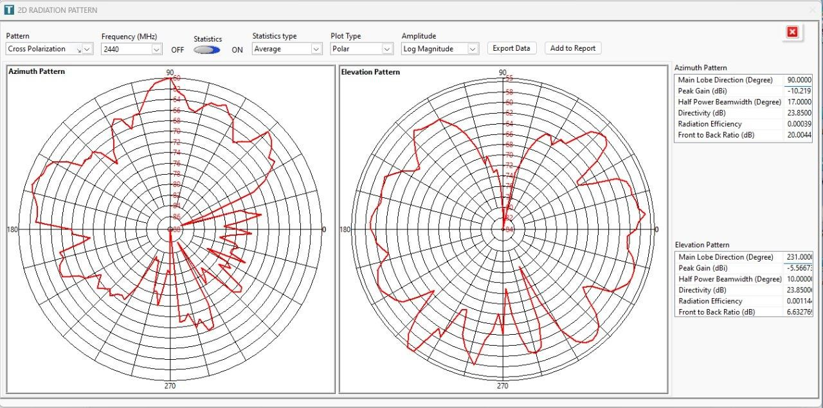

Fig.2.22: Radiation Pattern of Azimuth and Elevation Readings for cross polarization from anechoic chamber.

# 3. CONCLUSION

In conclusion, the implementation of an SDR-based receiver using STM32 microcontrollers and the NRF24L01 transceiver module presents a promising avenue for flexible and cost-effective wireless communication solutions. By using the capabilities of the STM32 microcontroller platform and the NRF24L01 transceiver's low-power wireless communication features, this approach offers us several key advantages in the field of wireless communication technologies. The se approaches are explained below one by one.

Firstly, the use of Software-Defined Radio (SDR) techniques enables us a greater flexibility and adaptability in signal processing and modulation/demodulation schemes of the signals. With the processing power of the STM32 microcontroller, various signal processing algorithms are implemented to support different wireless standards and protocols. This flexibility is particularly more valuable in various dynamic environments where the communication requirements may vary or evolve over time.

Additionally, The Presence of a matched impedance antenna is used to transmit and receive the signal at a bandwidth frequency of 2.4 to 2.525 GHz. The combination of STM32 microcontrollers and NRF24L01 transceivers offers a cost-effective solution for developing wireless communication systems.

In summary, the implementation of an SDR-based receiver using STM32 microcontrollers and NRF24L01 transceiver modules offers a powerful and versatile platform for developing wireless communication systems. With its flexibility, efficiency, and affordability, this approach holds great potential for various applications, including IoT devices, remote sensing, wireless sensor networks, and more.

# 4. FUTURE SCOPE

The main future scope of this project is building a sophisticated SDR that can be tuned in for wide bands with the support of multiple modulation schemes like frequency modulation, Amplitude modulation, quadrature amplitude modulation, etc. something like National Instruments USRP B-210 that supports a frequency range from 70MHz to 6GHz. Also, build a Graphical user interface with which the whole setup can be controlled and necessary changes can be made like that of GNU Radio.

Also, improvise on the digital signal processing capabilities by which we can manipulate, analyze, and decode radio signals in real time. Also, a small memory element can be added to save project files or the decoded signal. Further expansion can be achieved by using an FPGA (field programmable gate array) that increases the advantage by providing compatibility, expansion, and reconfigurability. Also, ethernet can be added in by which the whole device can be used over a Local Area Network (LAN).

# 5. REFERENCES

* + - 1. KiCad STM32 + RF + USB Hardware Design - Phil's Lab #5 [https://www.youtube.com/@PhilsLab](https://www.youtube.com/%40PhilsLab)
      2. RF PCB Design Guidelines <https://resources.pcb.cadence.com/blog/2023-rf-pcb-design-guidelines>
      3. How to get started with STM32CubeIDE from scratch <https://wiki.st.com/stm32mpu/wiki/How_to_get_started_with_STM32CubeIDE_from_scratch>
      4. Serial Peripheral Interface (SPI) https://learn.sparkfun.com/tutorials/serial-peripheral-interface-[spi/all#:~:text=Serial%20Peripheral%20Interface%20(SPI)%20is,you%20wish%20to](https://learn.sparkfun.com/tutorials/serial-peripheral-interface-spi/all#%3A~%3Atext%3DSerial%20Peripheral%20Interface%20(SPI)%20is%2Cyou%20wish%20to%20talk%20to)

[%20talk%20to.](https://learn.sparkfun.com/tutorials/serial-peripheral-interface-spi/all#%3A~%3Atext%3DSerial%20Peripheral%20Interface%20(SPI)%20is%2Cyou%20wish%20to%20talk%20to)

* + - 1. Interfacing NRF24L01 Transceiver Module with STM32 Tx/Rx <https://how2electronics.com/interfacing-nrf24l01-transceiver-module-with-stm32/>
      2. IMPLEMENTATION OF A SOFTWARE DEFINED RADIO ON FPGAs USING SYSTEM GENERATOR <https://scholar.utc.edu/cgi/viewcontent.cgi?article=1499&context=theses>
      3. USBLC6-2 Datasheet <https://www.st.com/resource/en/datasheet/usblc6-2.pdf>
      4. Design of Microcontroller-Based Automatic School Bell <https://www.researchgate.net/figure/Circuit-diagram-of-power-supply-> [unit_fig2_313838082](https://www.researchgate.net/figure/Circuit-diagram-of-power-supply-unit_fig2_313838082)
      5. NRF24L01 Datasheet - <https://datasheet.ciiva.com/18385/83-15187-18385942.pdf>
      6. STM32L496ZG Datasheet https://www.st.com/resource/en/reference_manual/rm0351-stm32l47xxx-stm32l48xxx-stm32l49xxx-and-stm32l4axxx-advanced-armbased-32bit-mcus-%20stmicroelectronics.pdf
      7. An Omni-Directional Wideband Patch Antenna with Parasitic Elements for Sub-6 GHz Band Applications https://doi.org/10.1155/2022/9645280
      8. X. Yang, Y. Liu and S. -X. Gong, "Design of a Wideband Omnidirectional Antenna With Characteristic Mode Analysis," in IEEE Antennas and Wireless Propagation Letters, vol. 17, no. 6, pp. 993-997, June 2018, doi: 10.1109/LAWP.2018.2828883.